C:\STOCKLAYOUTS\CURRENT PROJECTS\FN99807-PL\FN99807-IMG03.emf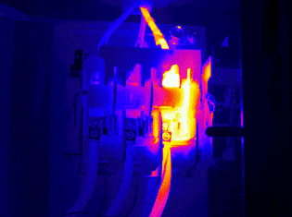

Thermographic Reports and Interpretations